Psalm 91
Deccember 1st, 2022

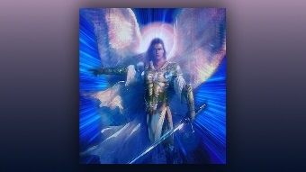
Amplified Bible
Security of the One Who Trusts in the LORD.

1He who [a]dwells in the shelter of the Most High
Will remain secure and rest in the shadow of the Almighty [whose power no enemy can withstand].
2I will say of the LORD, “He is my refuge and my fortress,
My God, in whom I trust [with great confidence, and on whom I rely]!”
3For He will save you from the trap of the fowler,
And from the deadly pestilence.
4He will cover you and completely protect you with His pinions,
And under His wings you will find refuge;
His faithfulness is a shield and a wall.
5You will not be afraid of the terror of night,
Nor of the arrow that flies by day,
6Nor of the pestilence that stalks in darkness,
Nor of the destruction (sudden death) that lays waste at noon.
7A thousand may fall at your side
And ten thousand at your right hand,
But danger will not come near you.
8You will only [be a spectator as you] look on with your eyes
And witness the [divine] repayment of the wicked [as you watch safely from the shelter of the Most High].
9Because you have made the LORD, [who is] my refuge,
Even the Most High, your dwelling place,
10No evil will befall you,
Nor will any plague come near your tent.
11For He will command His angels in regard to you,
To protect and defend and guard you in all your ways [of obedience and service].
12They will lift you up in their hands,
So that you do not [even] strike your foot against a stone.
13You will tread upon the lion and cobra;
The young lion and the serpent you will trample underfoot.
14“Because he set his love on Me, therefore I will save him;
I will set him [securely] on high, because he knows My name [he confidently trusts and relies on Me, knowing I will never abandon him, no, never].
15“He will call upon Me, and I will answer him;
I will be with him in trouble;
I will rescue him and honor him.
16“With a long life I will satisfy him
And I will let him see My salvation.”

